**HOMEPAGE**

**LOGIN  
   
REGISTER**

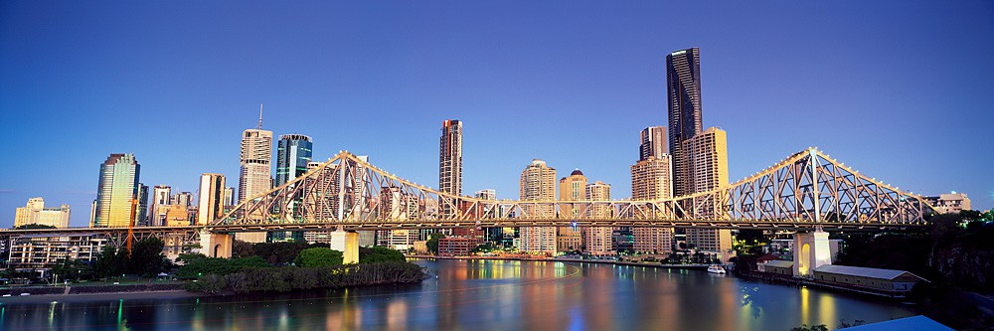

Logo Login and Register hyperlinks (press and it takes you to page)

Large image of Brisbane City

**LOGIN/ REGISTER PAGE**

Logo Login box including login button Register box



REGISTER

LOGIN

USERNAME

USERNAME

PASSWORD

PASSWORD

USER TYPE

(other relevant information that is needed

**LOGIN**

**REGISTER**



Register Button Banner of image of Brisbane

**ATTRACTIONS PAGE**

Close up version of map, pin points and   
more information on attractions etc.   
 Search Bar



SEARCH

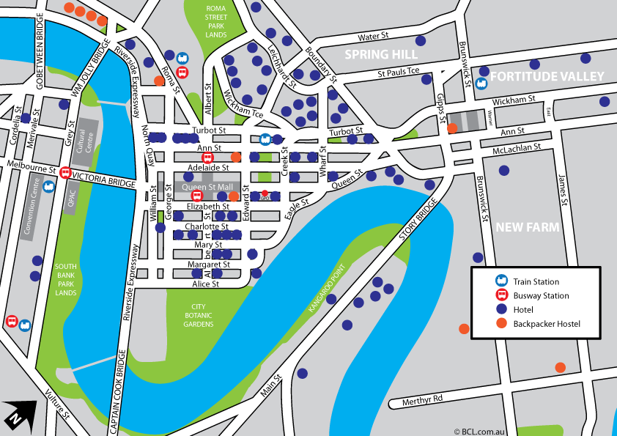

**VIEW CITY INFORMATION**

Hyperlink to view City Information

**STUDENT/ TOURIST/ BUSINESSMAN PAGE**

Depending on the chosen user type the pages for these will look similar to the ‘Attractions Page’, although the attractions will be relevant to either a student, tourist or businessman- showing only relevant information to that user. They will be able to access the city information and the search bar.